**About Credit Scorecards**

**What is a Credit Scorecard?**

Credit scoring is one of the most widely-used credit risk analysis tools. The goal of credit scoring is to rank borrowers by their credit worthiness. In the context of retail credit (credit cards, mortgages, car loans, etc.), credit scoring is usually performed using a credit scorecard, where different characteristics of a customer (age, residential status, time at current address, time at current job, and so on.) translates into points, and the total number of points become the credit score. The credit worthiness of customers is summarized by their credit score; high scores usually correspond to low-risk customers, and vice versa. Scores are also used for corporate credit analysis of small and medium enterprises, as well, as and large corporations.

A credit scorecard is a lookup table which maps specific characteristics of a borrower into points. The total number of points becomes the credit score. Credit scorecards are a particular and widely-used type of credit scoring model. As such, the goal of a credit scorecard is to distinguish between customers who will repay their loans ("good" customers), and customers who won't ("bad" customers). Like other credit scoring models, credit scorecards quantify the risk that a borrower will not repay a loan in the form of a score and a probability of default.

For example, a credit scorecard may give individual borrowers points for their age and income according to the following table. Other characteristics such as residential status, employment status, and so on, may also be included, although, for brevity, they are not shown in this table.

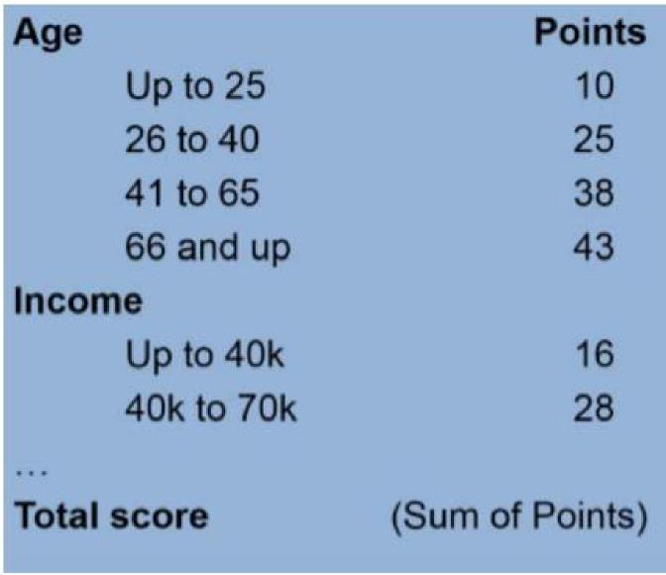

Using the credit scorecard in this example, a particular customer who is 31 years old and has an income of $52,000 a year, is placed into the second age group (26 to 40) and receives 25 points for his age, and similarly, receives 28 points for his income. Other characteristics (not shown here) might contribute additional points to his score. The total score is the sum of all points, which in this example is assumed to give the customer a total of 238 points (this is a fictitious example on an arbitrary scoring scale).

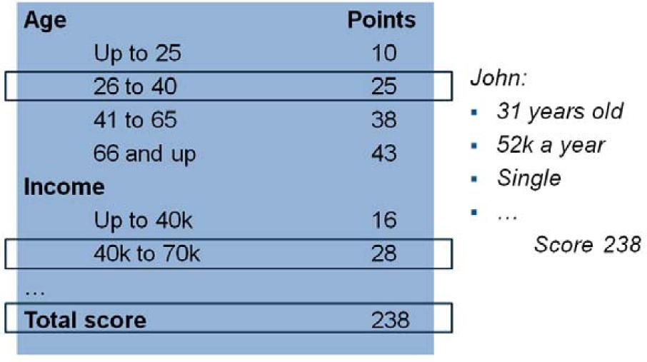

Technically, to determine the credit scorecard points, you must start out by selecting a set of potential predictors (column 1 in the figure below). Then you need to bin data into groups (for example, ages ‘Up to 25', '25 to 40', and so on (column 2 in the figure). This grouping helps to distinguish between "good" and "bad" customers. The weight of evidence (WOE) is a way to measure how well the distribution of "good" and "bad" are separated across bins or groups for each individual predictor (column 3 in the figure). By fitting a logistic regression model, you can identify which predictors, when put together, do a better job distinguishing between "good" and "bad" customers. The model is summarized by its coefficients (column 4 in the figure). Finally, the combination of WOE's and model coefficients (commonlly scaled, shifted, and rounded) makeup the scorecard points (column 5 in the figure).

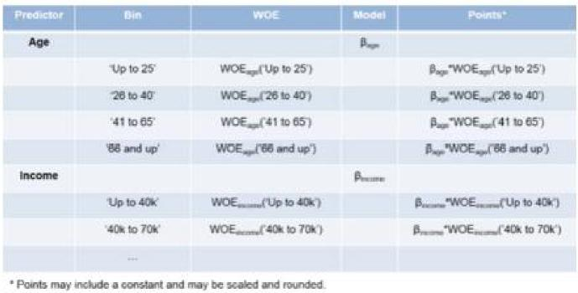

**Credit Scorecard Development Process**

Overall, there are three phases for developing a credit scorecard model:

1. Data gathering and preparation phase

This includes data gathering and integration, such as querying, merging, aligning, and so on. It also includes treatment of missing information and outliers. There is a prescreening step based on reports of association measures between the predictors and the response variable. Finally, there is a sampling step, to produce a training set, sometimes called the modeling view, and usually a validation set, too. The training set, in the form of a table, is the required data input to the creditscorecard object, and this training set table must be prepared prior to creating a creditscorecard object in the Modeling phase.

1. Modeling phase

Use the creditscorecard object and the associated object functions to develop a credit scorecard model. You can bin the data, apply the Weight of Evidence (WOE) transformation, and compute other statistics, such as the Information Value. You can fit not only a logistic regression model but also review the resulting scorecard points and format their scaling and rounding. For more information on using the creditscorecard object, see Using creditscorecard Objects.

1. Deployment phase

Deployment entails integrating a credit scorecard model into an IT production environment and keeping track of logs, performance reports, and so on.

The creditscorecard object is only designed for the Modeling phase of the credit scorecard workflow. Support for all three phases requires other MathWorks® products.

**See Also**

autobinning | bindata | bininfo | creditscorecard | displaypoints | fitmodel | formatpoints | modifybins | plotbins |

score | setmodel

**Related Examples**

Troubleshooting Credit Scorecard Results
  
Case Study for a Credit Scorecard Analysis

**More About**

Credit Scorecard Modeling Workflow